RC Excavator used I2C channels:  
  
I2C addresses used in the project. Please look up individual part documentation for more information.

For checking current active channels in Raspberry pi, please run:

*sudo apt-get install i2c-tools*

*i2cdetect -y 1*

|  |  |  |  |  |
| --- | --- | --- | --- | --- |
| **Raspberry I2C:** | **Addr 1** | **Addr 2** | **Addr 3** | **Addr 4** |
| **ADCPi HAT** | 0x6E | 0x6F | - | - |
| **Adafruit 16-channel PWM HAT** | 0x40 | - | - | - |
| **Adafruit Multiplexer** | 0x71 | - | - | - |
| **Adafruit 128x64 OLED** | 0x3D | - | - | - |
|  |  |  |  |  |

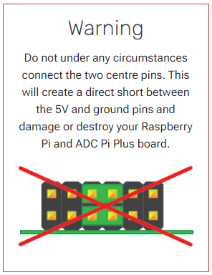

Image 1. ADCPi-hat warning.

Image 2. ADCPi channel configuration. Channels 0x6E and 0x6F used

Image 3. Example configuration for board2

Image 4. Adafruit 16 Channel PWM-hat. Address 0x40 used.

Image 5. Adafruit PCA9548A Multiplexer. Channel 0x71 used.

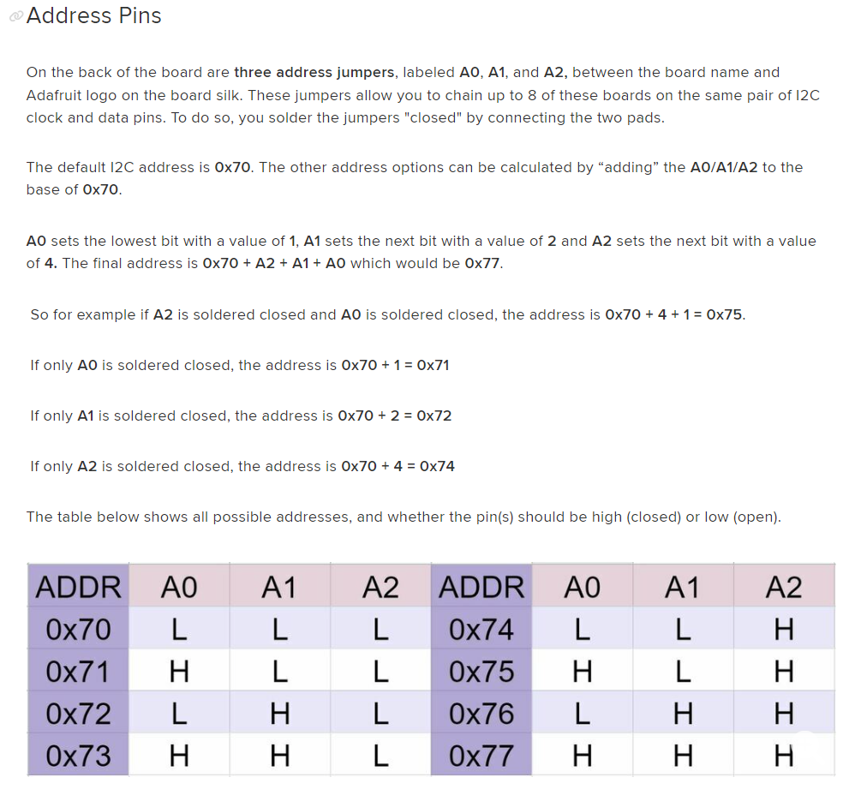

Image 6. Multiplexer pin logic.

Image 7. Adafruit 128x64 OLED screen. Channel 0x3D used.